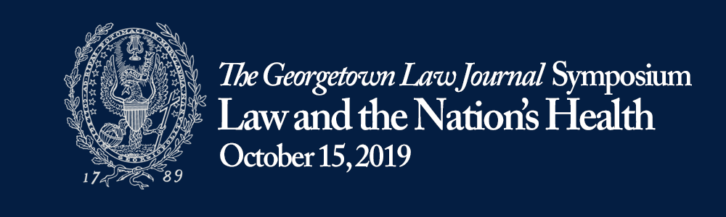

9:30 A.M. – 9:45 A.M. Introductory Remarks
Caitlin Haynes • The Georgetown Law Journal
John T. Monahan • Georgetown University

9:45 A.M. - 11:15 A.M. The Affordable Care Act 10 Years On
David Hyman • Georgetown University Law Center
Abbe Gluck • Yale University School of Law
Dayna Bowen Matthew • University of Virginia School of Law
M. Gregg Bloche • Georgetown University Law Center
Moderated by Emily Whelan Parento, Louis D. Brandeis School of Law at the University of Louisville

11:15-11:30 A.M. Coffee & Tea Break

11:30 A.M. - 12:30 P.M. Keynote Address
Lawrence O. Gostin • Georgetown University Law Center
Introduction by Tony Fauci

12:30 – 1:30 P.M. Lunch

1:30 P.M. - 2:45 P.M. The Law of Women’s Health and Equity
Helen M. Alvare • Antonin Scalia Law School, George Mason University
Mary T. Bassett • Harvard University
Jennifer Prah Ruger • University of Pennsylvania
Moderated by Nan Hunter, Georgetown University Law Center

2:45-3:00 P.M. Coffee & Tea Break

3:00 P.M. - 4:15 P.M. Developments in Global Health Law
I. Glenn Cohen • Harvard Law School
Sam Halabi • University of Missouri School of Law
Rebecca Reingold • Georgetown University Law Center
Moderated by Maeve McKean, Georgetown University

4:15 P.M. - 4:30 P.M. Closing Remarks
Caitlin Haynes and Grace Paras • The Georgetown Law Journal

4:30 P.M. - 6:00 P.M. Reception

