7/10/2018

Georgetown LaW
Events GUIDE
for Student organizations events

Table of Contents

- Event Planning
- Event Planning and Management
- Responsibilities of the Event Organizer
- Event Planning Checklist
- Event calendar and Flyer

- How to Reserve a Room
- Reservation Process (Virtual EMS, Student Life Office)
- Changes and Cancellation Procedures

- Facilities Room/Space Information
- Event Space Information
- Room Setup Diagrams for Flexible Event Spaces

- Event Support Services
- Audio Visual Services and Equipment
- Facilities Services and Room Setup

- GULC Events Policies

EVENT SUPPORT SERVICE HOURS: (Closed on holidays)

Audio Visual Services – Monday- Friday 8:00AM- 9:00PM
Closed on Weekends

Facilities Management – Monday- Tuesday 8:00AM- 3:30PM
Wednesday- Friday 8:00AM-7:30PM
Saturday – Sunday 8:00AM- 3:30PM

Public Safety – 24/7 Main Line 202-662-9325
Public Safety Management Office- Monday- Friday 7:00AM- 5:00PM
McDonough 102, lawpolice@georgetown.edu
Office of Student Life -- Main Line 202-662-9292, lawstudentlife@georgetown.edu
Office of Communications -- Monday- Friday 9:00AM- 5:30PM
202-662-4199, mediarelations@georgetown.edu

Office of Special Event

Preface

We have produced this guide to help you through the process of planning your event. You will find checklists, helpful hints, as well as procedures to assist you in your planning.

This guide will provide you with basic information about our facilities and guide you through the initial planning process. We also encourage you to keep in contact with our dedicated staff who are ready to help you plan a successful event.

Georgetown University Law Center
600 New Jersey Avenue, NW
Washington DC 20001

Checklists

- Faculty
- Centers and Institutes
- Student Organizations
- External Group

Event Planning

Event Planning and Management

Events are critical tools for institutional advancement. Some of the basic issues surrounding events are very straightforward: location, date, time, etc.

Please ensure you check with Office of Student Life/ Office of Special Event regarding any necessary approvals needed for your event.

A successful conference or meeting takes time and forethought, and we encourage you to begin early. Large, complex events may require many months of preparation and should be booked as soon as possible. Please note that the demand for event space is high at Georgetown Law, so we recommend that you book and begin planning your event as soon as possible.

Event Organizer Responsibilities

Event organizers are expected to:

Contact Student Life and fill out necessary forms in Orgsync to beging the approval process.

Input accurate and complete information into EMS when you reserve a space at https://eventspace.georgetown.edu/virtualems/ or from the GU Law website at https://www.law.georgetown.edu/your-life-career/campus-services/information-systems-technology/classroom-and-av-services/forms/ at least 2 weeks prior to the event with details of Audio Visual, Facilities and Public Safety services.

Your event request can be updated for minor set up changes only in EMS no later than 72 business hours of the event date.

Questions, concerns or a walkthrough request for Facilities Management/ Audio Visual or Public Safety must be sent to lawstudentlife@georgetown.edu. Please note that requests sent to this email are not guaranteed an immediate response and it is best to follow up with an individual within the office via a call or separate email.

Any event that is either live streamed or recorded, and will be posted must have closed captioning. The Law Center’s AV department will schedule these services and charge your worktag. Input the Student Organizations’ worktags in EMS for Closed Captioning Services.

Be in attendance one hour prior to the event to confirm setup and get yourself familiar with the Audio Visual system at the event space.

Conduct events so that it starts and ends on time. This especially important if your event is live webcasting.

Comply with local, state and federal laws contact DPS with questions or concerns at (202) 662-9325 to request to speak with a supervisor or email lawpolice@georgetown.edu

If Media may be present, please contact the Office of Communications at mediarelations@georgetown.edu

Things to Consider for Your Event

This Event-Planning Do-Don’t list was developed to assist staff, faculty and students when they are organizing lectures, readings, panel discussions, symposia, workshops, meetings, conferences, etc. Not all items on the list will be relevant to every function.

DO…
- Include in EMS form:
Event contact name and phone
Event Name
Event Location
Room reservation start and end time
Event start and end time (Note: Start time is when moderator starts presenting to audience)
Facilities set-up, Public Safety and AV requirements with the set-up diagram attachment
Number of people planned to attend
- Loop in Communications
- Turns lights off when leaving.
- Evenings and weekends: Notify DPS when you arrive and leave your space.
- Adhere to confirmed event start and end times.

- Separate AV/ Facilities request needs to be filled out for each Major Site
- Always attach the event agenda and diagram
- Request form must be submitted at least 2 weeks in advance of Event Start Date; or the request will be denied
- Request table linens through catering
- Update changes at least 72 business hours prior to your event for minor changes only
- Remember classes are in session. Keep sound down whenever possible.
- Notify Facilities of any excess trash.

DON’T…

- Unplug or move computers, AV equipment set up for event.
- Remove dry erase pens/ Flip chart/ pad.
- Move existing furniture.
- Use pushpins or tape on walls.
- Use confetti during your event. It kills vacuums and hurts the environment.
- Use grills, open fires, candles and any form of Incendiary equipment (requires prior authorization)
- Prop open exterior doors

Department of Public Safety (DPS)

- DPS Chief and/or Deputy Chief should be notified in advance (one week before event) of high level VIP visit.
- Do consider that during weekends and non-business hours, public entrances are closed and not staffed. Therefore, if you anticipate an event running late or being held over a weekend and will need building access, please contact DPS to make arrangements. Average overtime rate per officer is about $32 per hour.
  - McDonough Hall: Mondays through Fridays, 7am - 10pm.
  - Hotung Hall, located on the F Street NW side is only open and staffed during hours when the Sport & Fitness Center is open.
  - Parking Booth staffed Mon - Fri, 7am - 6pm
  - Gewirz Student Center: 7am - 3:30pm
- If you anticipate a large number of non-Georgetown University-affiliated attendees, do provide a list of registered attendees to DPS ahead of time so they can be prepared
- Advise non-Georgetown University affiliated attendees that they will have to show photo ID and be signed in if they're not registered for the event
- Do advise attendees that there is no public parking on campus. If speakers or other VIPs require parking, please contact the Parking Office and DPS so that the appropriate arrangements and notifications can be made.
- If VIP expected (with or without an additional security detail), please notify DPS so that appropriate arrangements can be made with protective/security teams, as needed
- Do advise attendees with accessibility issues as handicapped-accessibility access routes to the building where the event is being held
- Please use the proper address for where the event is being held to minimize confusion for off-campus attendees:
  - McDonough Hall / Hart Auditorium: 600 New Jersey Avenue NW
  - Hotung / Sport & Fitness Center: 550 1st Street NW
  - Gewirz Student Center: 120 F St NW
- If the event will be catered, make arrangements with Facilities and DPS in advance to ensure caterers have needed access to building(s) as well as parking available (as needed)

Office of Communications

When initial planning begins for an event at the Law Center, particularly if it involves faculty, Centers & Institutes staff or high profile external individuals, we ask that the organizers notify our Communication team in order to discuss potential Georgetown Law and external media coverage. This information is helpful to have, even before the event agenda is finalized.

QUESTIONS:

- Will outside media be invited to cover the event?
- Have the speakers and guests been advised that their remarks may be covered by outside media or Georgetown Law's own platforms? (Web, Magazine, Social Media)
- If media will be invited to cover, has a mult box been requested from AV?
- C-SPAN -- if they are invited and plan to attend, have arrangements been made for advance set-up? Has Public Safety been notified of any doors and entrances that need to be opened for the crew?
- Has a photographer been hired?
- Will the event be live-streamed? If so, have arrangements been made with the AV department for closed captioning (required)?

Event Calendar and Flyer

Every morning, the Student Life Office will post a daily event calendar to the GULC community in the elevators in each building. Student Groups must submit a request form in Orgsync.com for permission to post flyer, poster and digital advertisement for their events. The flyer and poster must post on the designated area only.

How to Reserve a Room

- Reservation Process

Reserving an event space is quite simple.

- For staff, go to https://eventspace.georgetown.edu/virtualems/, select the time and date, reserve the room, and you will receive a reservation number via email confirmation.
- For student organization, fill out the Special Events Request Form in Orgsync.com or submit a hard copy at Student Life Office at McDonough 212. Then you will receive an email confirmation with the reservation number.
- For student organization, input the room reservation number and your event information into the SharePoint event form. Be sure to submit SharePoint request 2 weeks prior to your event date regardless of receiving the room confirmation.
- For student organization, you will receive a confirmation email from SharePoint to confirm that the form has been successfully submitted. You will be contacted by the Office of Student Life if there are any questions regarding the event set-up.

Changes and Cancellation Procedures

- If changes are to be made, you should re-visit the event in EMS and modify the details as needed. There are also options available to cancel or re-schedule the event.

- There is a 48-hour freeze on changes within SharePoint – please call the Office of Student Life directly if you need to change anything within the 24-hour period prior to your event. Once verbal approval is given, please update the SharePoint events form with the new information and the fact that those were approved – please include the name of the person who approved the changes.

- If there is a cancellation or change in date, time, location or speaker (s), also please notify Student Life Office and/or the Office of Special Events so online/print public calendars can be updated in a timely fashion.

Room Information

- Event Space Information

GULC has three buildings with event spaces that can accommodate various events and meetings.

  - McDonough Hall / Hart Auditorium: 600 New Jersey Avenue NW
  - Hotung / Sport & Fitness Center: 550 1st Street NW
  - Gewirz Student Center: 120 F St NW
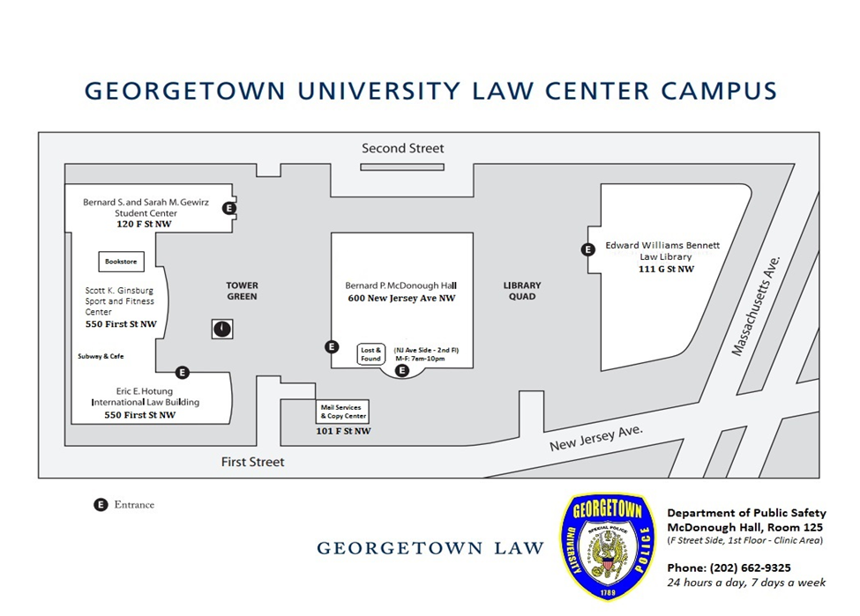

Overview: Room Setup/ Technology

 | Gewirz 12th | Sport & Fitness Lobby | Hotung Dinning (2001) | Faculty Lounge (520) | Hotung Lobby | Hart Auditorium
BUILDING | Gewirz | Hotung | Hotung | McDonough | Hotung | McDonough
ROOM SETUP
Theater
U Shape
Hollow Square
Banquet
Reception (standing)
Conference Style
TECHNOLOGY
Video Conferencing |  |  | ZOOM | ZOOM
Video Recording | X | X | X | X | X | X
Web Streaming | X |  | X | X |  | X
Audio Conferencing | X |  | X | POD or ZOOM |  | X
Audio Recording | X | X | X | X | X | X
Projection | X | X | X | X | X | X
Public Address support | X | X | X | X | X | X

*Facility Department and Audio Visual Services do not provide table clothes, which should be provided or rented through an event caterer.

Event Support Services

Audio Visual and Facilities resources are provided on a limited basis. Clients may need to rent additional Audio Visual and Facilities resources based on available inventory.

Audio-Visual Support - The Audio Visual Services offers the following technology services for deployment in conjunction with supporting the various meetings, classes and events taking place on the GULC campus –

  - Zoom Video Conferencing - multiple sites
  - Video Recording
  - Web Streaming – Closed Captioning required
  - Zoom Audio Conferencing – (teleconference)
  - Audio Recording
  - Projector Display from Laptop/PC
  - CD/DVD movies
  - Audio support utilizing microphones, includes table, lavaliere and hand held microphones
  - Auxiliary camera and audio support requiring substantial lead time such as TV networks, including the use of Multboxes
  - PowerPoint wireless remote clicker
  - Simultaneous translation service coordination – we will ensure the audio is working properly; the service itself must be arranged independently.

Event coordinators are expected to be familiar with the classroom technology for basic configuration for their event needs. AV Services can help provide the necessary training ahead of an event.

The Audio Visual Services does not provide table clothes for panel, power strips and the support off campus.

- Public Safety/ Facilities Support

- VIP Parking, Media and VIP Security
- Contact DPS either via telephone (request to speak with supervisor) or email, make arrangements
- Much of the above can be reiterated here as well
- Facilities Management supports all the events that take place at GULC throughout the year

- The Facilities will provide and set up the event space according to instruction you input into the SharePoint Form only: Chairs – Tables – Stages-- White Boards
- Outside vendors are responsible for their equipment, furniture, staging and miscellaneous materials. They are also responsible for their removal.

- Facilities does not set up linens or any equipment belonging to outside vendors/independent contractors such as caterers, speakers, musicians, etc.

- For information pertaining to VIP Parking, Media and VIP Security, please contact Public Safety at lawpolice@georgetown.edu and Facilities Management at lawfacilitiesmgmt@georgetown.edu . Input this information into the SharePoint event form.

GULC Events Policy for Event Sites

1. GULC Academic Programs, Research Institutes and the Administration will be provided a venue (as available) and support from Facilities Management/Audio Visual Technicians:
- During normal business hours listed above
- Overtime/Time-and-a-half ($30 per hour) charges apply to all off-hours events
- Event organizer must completely fill out the online events form and provides this information at least 15 business days prior to the event. Rare exceptions to this policy for last-minute, high-level speakers can be considered on a case-by-case basis.
- Special Event Office and Student Life Office reserve the right to prioritize events, venue assignments.

2. Non-Georgetown University Entities GULC reserves the right to deny venue based on internal needs.
- All inquiries affiliated with student organizations must contact Office of Student Life.
- All inquiries by non-GULC Entities should contact the Office of Special Event.
- Office of Student Life reserves the right to expropriate the space for priority events deemed critical to the mission of the school.
- GULC events always have priority to venues and Facilities/AV support.
- Should GULC Entities be granted a venue during off hours, they must pay the off-hours rate and will be required to contract out AV support.

APPENDIX – CAMPUS ROOM CAPABILITY SUMMARY

Location (Building) | Location (Room) | No. of seats | Room Type | Configuration | Technology Features included in the Room
McDonough | Hart Auditorium | 375 | Event Site | Event site | 3 Adjustable (Pan & Tilt) Video Cameras, Wireless Internet, Blu-ray player,  HD Projector, Electric Projection screen, PA system
Gewirz | 12th Floor | 0 | Event site | Event site | 1 static video camera, Crestron Control, PA system, Wireless  Internet
Hotung | 1000 | 70 | Classroom | Academic | 1 adjustable camera, Apple TV, BluRay, Echo360, HD Projector, Electric  Projection screen, PA system, ceiling audio recording, Wireless Internet, zoom conference
Hotung | 2000 | 60 | Classroom | Academic | Zoom Enabled Student Microphone, Cisco Video conferencing, 2 adjustable cameras,  Apple TV, BluRay, Echo360, HD Projector, Electric Projection screen, PA system,  ceiling audio recording, Wireless Internet
Hotung | 2001 | 48 | Seminar, Event site | Seminar, Event site | 1 Adjustable (Pan & Tilt) Video Cameras, Standard Projector, Electric Projection  Screen, PA system, ceiling audio recording, Wireless Internet
Hotung | 2003 | 0 | Classroom | Moot Court | 4 Adjustable (Pan & Tilt) Video Cameras, HD Projector, Document camera,  PA system, Wireless Internet
McDonough | 200 | 75 | Classroom | Academic | Zoom Enabled Student Microphone, Cisco Video Conference, 3 Adjustable (Pan & Tilt)  Video Cameras, Apple TV, Blu-ray, Echo360, voice jack at professor desk,  HD Projector, Electric Projection screen, PA system, ceiling audio recording,  Document camera, Wireless Internet
McDonough | 520 | 0 | Event site | Event site | Wireless Internet, ceiling audio recording, zoom conference
Gewirz | 108/ Flegal | 12 | Classroom | Moot Court | 4 Adjustable (Pan & Tilt) Video Cameras, Wireless Internet, voice jack at professor  desk, Flat Panel projector, Document camera, Audio recording, USB memory stick recording

Classroom Technology
The following minimum level of technology exists in all classrooms across the Law Center:
- PC with most common apps and utilities – with All-In-One Multi-touch screen;
- Wireless keyboard and mouse;
- Webcam;
- Zoom web conferencing software;
- Apple TV for wireless projection from Apple devices;
- Dome HD camera for lecture capture;
- Echo 360 Lecture Capture appliance;
- DVD player;
- Speakers with amplification;
- Rack with HDMI, VGA, and audio inputs for external devices;
- Projector with screen;
- PA system — Level 2/3;
- Lavalier and lectern microphone — Level 2/3
All classrooms are also equipped with a wall phone with speed dials to Security, Technology Service Desk and Facilities and the ability to dial internal extensions. Classroom checks are executed every morning in order to ensure that the technology in every classroom is fully operational.
(Note: For detailed information, please visit the Classroom AV Inventory.)

